**Locating Elements through CSS and XPath**

**LocatingElementsDemo.java**

**package** com.ecommerce.test;

**import** org.openqa.selenium.*;

**import** org.openqa.selenium.chrome.ChromeDriver;

**import** org.openqa.selenium.firefox.FirefoxDriver;

**import** org.openqa.selenium.ie.InternetExplorerDriver;

**import** org.openqa.selenium.support.ui.Select;

**public** **class** LocatingElementsDemo {

**public** **static** **void** main(String[] args) **throws** InterruptedException {

WebDriver driver = **new** ChromeDriver(); // new FirefoxDriver();

// Demo locating by id, name and class

// googleAccCreation(driver);

// Demo cssSelector

*facebookAccCreation*(driver);

//close the browser and quit.

//driver.close();

}

**static** **void** facebookAccCreation(WebDriver driver) {

String baseUrl = "https://www.facebook.com/r.php?locale=en_GB&display=page";

driver.get(baseUrl);

String cssDay = "#day";

WebElement cssDaySelect = driver.findElement(By.*cssSelector*(cssDay));

Select daySelect = **new** Select(cssDaySelect);

daySelect.selectByVisibleText("11");

// PROBLEM : locate the gender element and try setting it F/M/C

// String cssGender = "#u_0_4_nJ";

// WebElement cssGenderRadio = driver.findElement(By.cssSelector(cssGender));

// cssGenderRadio.click();

WebElement cssGenderRadio = driver.findElement(By.*cssSelector*("span > span > input[type='radio'][value='2']" ));

cssGenderRadio.click();

// Demo find by tag name

WebElement titleTagElement = driver.findElement(By.*tagName*("title"));

System.***out***.println("WebPage Title is "+titleTagElement.getText());

}

**static** **void** googleAccCreation(WebDriver driver) {

String baseUrl = "https://accounts.google.com/signup/v2?biz=true&flowEntry=SignUp";

driver.get(baseUrl);

// Let's locate the first name text field by its id.

WebElement firstNameTF = driver.findElement(By.*id*("firstName"));

firstNameTF.sendKeys("Myname");

// Let's locate the surname name text field by its name.

WebElement surNameTF = driver.findElement(By.*name*("lastName"));

surNameTF.sendKeys("latName");

// The Next button using its class

WebElement nextButton = driver.findElement(By.*className*("VfPpkd-vQzf8d"));

System.***out***.println("Text on the button is "+nextButton.getText());

nextButton.click();

// String dayXPath ="/html/body/div[1]/div[1]/div[2]/div/div[2]/div/div/div[2]/div/div[1]/div/form/span/section/div/div/div[1]/div[1]/div/div/div[1]/div/div[1]/input";

// WebElement dayTF = driver.findElement(By.xpath(dayXPath));

// dayTF.sendKeys("10");

// String dayRelativeXPath = "//*[@id=\"day\"]";

// WebElement dayTF1 = driver.findElement(By.xpath(dayRelativeXPath));

// dayTF1.sendKeys("10");

// WebElement dayTF1 = driver.findElement(By.id("day"));

// System.out.println("dayTF1 "+dayTF1);

// dayTF1.clear();

// dayTF1.sendKeys("10");

}

}

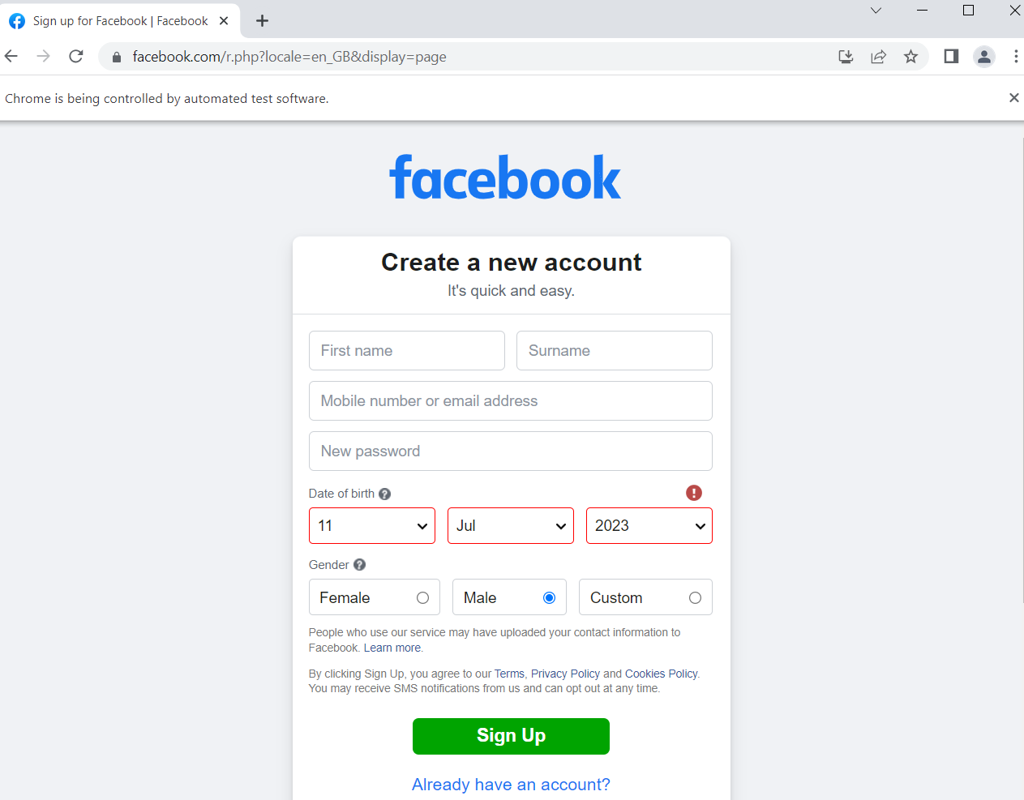

**package** com.ecommerce.test;

**import** java.util.List;

**import** org.openqa.selenium.*;

**import** org.openqa.selenium.chrome.ChromeDriver;

**public** **class** AdvancedLocateElementDemo {

**public** **static** **void** main(String[] args) **throws** InterruptedException {

WebDriver driver = **new** ChromeDriver(); // new FirefoxDriver();

String baseUrl = "File:///C:\\Users\\HP\\eclipse-workspace5\\hello-selenium1\\src\\main\\resources\\test.html";

driver.get(baseUrl);

List<WebElement> inputAdminElements = driver.findElements(By.*xpath*("//input[contains(@id, 'admin')]"));

System.***out***.println("inputAdminElements has "+inputAdminElements.size());

//close the browser and quit.

//driver.close();

}

}

